.
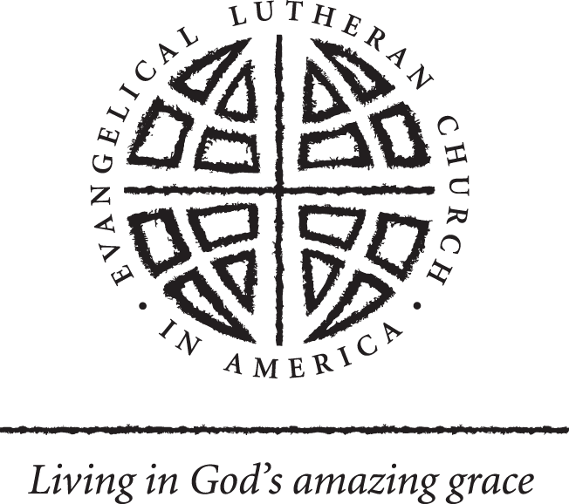 ZIP Code Report: Congregational User’s Guide

The ZIP Code report reflects the 2009 estimates and 2014 projections. It compares the ZIP Code requested to the county in which it resides. There are a number of ways the data in this report can be used. For example, you may ask, how does my area compare to the county? Is my area higher, lower or on par with the county data? If you serve more than one ZIP Code, are they similar or different? How does that affect your congregation’s ministry?

- Population Change provides a brief synopsis of what has, what is, and what will happen to the population. If an area is growing, particularly at a fast rate, you may need to think about building an addition to accommodate the needs of new members. If an area is declining, consider why. Is it because a major industry closed down and folks are moving to find other jobs? Is it because the area is in racial/ethnic transition? A transitional phase will probably mean you need to start thinking about an outreach program to those who are moving into the area.

- Population by Race can help you get a picture of your area. This is helpful for the new pastor or for areas in transition. Does the membership of the congregation reflect the racial make-up of the community? The Population by Race can help determine if there should be outreach or a new service in different languages. Is your area comprised mainly of new immigrants? Maybe you can sponsor an English as a Second Language (ESL) program at your congregation.

- Population by Age will tell the age composition of the area. For instance, your area may show 20% 25-34 year olds and 10% 0-4 year olds. This would indicate parents with young children in the area. The age composition can also help determine the need for additional ministries such as day care or a senior center.

- The income section on the ZIP Code report can hint at expectations of regular giving. Or, it may inspire you to start a food pantry, contribute to local charities or provide support for transitional housing.

- Educational Attainment can help a congregation determine guests for workshops, adult education forums, speakers and topics.

- Marital Status and Households by Type provide insight into the ministries that you have or can start at your congregation. If the percentage of population which is divorced is large in your area, there may be a need for support groups. If there is a high percentage of single parents/caregivers, there may be a need for a day care center, a pre-school or other ministries.

- The Estimated Housing Units by Year Structure Built can tell whether the area is established or if it contains newer housing. Older housing can mean empty-nesters or senior citizens reside in the area. New housing typically means growth.

