This guide will help you record and upload a strong video essay for your scholarship application. The video must be no longer than 6 minutes.

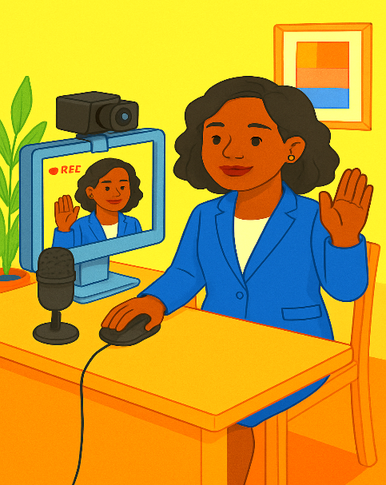
Best Practices:
Preparing Your Recording Space
- Find a quiet, well-lit space.
- Face a window or soft lamp for better lighting.
- Keep the background simple and uncluttered.
- Avoid noisy or distracting locations.
- Do not sit in a chair that moves or rocks

Dress and Body Language
- Wear simple, respectful clothing (solid colors work best).
- Sit upright and look directly into the camera lens, do not look at yourself on the screen.
- Speak as if you are talking to a trusted mentor.

Understanding the Prompts
- Read each essay question carefully.
- Take time to reflect before you start recording.
- Write down a few key thoughts you want to cover.

Welcome + Overview
- Introduce yourself by stating your full name.
- say what degree you are planning to pursue.
-tell us what your synod of candidacy is.
- Remember: the goal is clarity, honesty, and authenticity.

Speak Clearly + Subtitles
- Speak at a relaxed pace and enunciate your words.
- If English is not your first language, consider adding English subtitles (not required).
- Subtitles help reviewers understand your story fully.
- YouTube provides tools to add subtitles.

Tip: Keep your video under 6 minutes. Practice once or twice before recording the final version.

Finally
- Remember: this video is not about perfection.
- Focus on being authentic and sharing your story.
- Your experiences matter, and we are cheering you on as you begin your seminary journey.

Upload to YouTube or Vimeo
- After recording, upload your video to YouTube or Vimeo.
How to Upload:
- Open the YouTube app.
- Tap Create Video.
- Select the file you'd like to upload and tap NEXT.

- Select **Unlisted** so only people with the link can view it, or mark Public, do not mark Private.
- Copy the video URL.
- Paste the URL link into your scholarship application.

