

Confession and Repentance for the Sins of Patriarchy and Sexism:
A Worship Guide
Introduction
An evening prayer service was held at the 2025 Churchwide Assembly that included an order of confession and forgiveness for the sins of patriarchy and sexism. This was, in part, to fulfill an implementing resolution to the 2019 social statement, Faith Sexism, and Justice: A Call to Action. Yet this service was not a one-time event, but the beginning of an ongoing process valuable to worshipping communities across the church.

When we confess, we do so as individuals and as part of the Christian community. Part of confession is acknowledging communal sin. As a hymn by Brian Wren states, “We come with self-inflicted pains of broken trust and chosen wrong, half-free, half-bound by inner chains, by social forces swept along, by powers and systems close confined, yet seeking help for human kind” (“Great God, Your Love Has Called Us,” ELW 358). This resource is provided with the understanding that confessing together as the body of Christ matters.

You may consider this helpful note from Forgive Us and Transform Us for the Life of the World, p. 46, for use in a worship folder to help set the context.

What is Confession?
Luther teaches us that confession has two parts that work together: we tell God our sins and we receive God’s forgiveness (Small Catechism, Part V: Confession). When we confess, we’re living out our faith — we’re being honest about the ways we’ve hurt ourselves, the neighbor, and creation, by what we’ve done and what we’ve failed to do. Picture it like standing in a bright light; everything is visible, but instead of this provoking fear, it becomes freeing. No matter what you confess, God’s love will never abandon you — it’s a promise.

What is Repentance? Repentance goes deeper than just feeling bad about what we’ve done wrong. It’s about truly changing how we live and act. Think of it as making a complete turn — away from harmful ways and toward God’s way of love and justice. To be clear, we don’t make this turn by our own strength. The Holy Spirit does this work in us, giving us courage to think and live differently. Luther explains in the Smalcald Articles that true repentance includes both truly being sorry for our sins and deeply believing that Christ forgives any and all sins (Smalcald Articles, Part III, Article III). This coming together of being and believing leads to the change in how we act and live; it leads to transformation. --from Forgive Us and Transform Us for the Life of the World, p. 46

How to Use this Resource
This worship guide was developed to aid worshiping communities in planning and leading services centered around this confession and repentance. This confession could take place during a service of holy communion or as part of a daily prayer service. It could be used in synod events or other gatherings. A briefer, more general confession is also provided for times when that may be desired.

You may choose to use certain elements such as the confessions or select prayers, or you may decide to shape a full service using multiple elements. Although many prayers are provided, it is not suggested to use them all, but to choose what will suit your specific context. If you desire to hold a service outside of a Sunday morning Holy Communion liturgy, consider using the framework “Service of Word and Prayer” in All Creation Sings, using the Confession either as part of the Gathering or Word portion of the service.
Confession
The Confession below could be used as part of the Gathering in a service of Holy Communion or following the reading of scripture in a prayer service. Since this confession was crafted for a specific occasion, you may consider adapting as desired for your context. An alternate brief order for confession and forgiveness is provided on page 4 and could be used as part of the Gathering in a service of Holy Communion.

Confession and Repentance for the Sins of Patriarchy and Sexism
The presiding minister begins.
Good and gracious God,
you have created us for flourishing and abundance,
yet we deny and diminish the promises you have made to us
and all creation.

We come before you in confession and repentance
for the sins of patriarchy and sexism,
seeking forgiveness and transformation.

Let us confess our sin
in the presence of God and of one another.

Silence for is kept for reflection.

The following portions could be read by one or several people depending on your context. Note that some sections intend a female voice, while others could be read by people of all genders, ages, backgrounds, and abilities. Brief pauses after each assembly response are strongly suggested, and reading the response in several languages is encouraged.

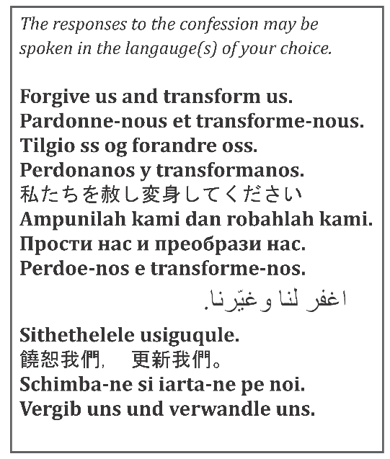
Creator of the cosmos,
we confess our complicity in the sins of patriarchy.
You envision communities built on mutuality, wonder,
and neighbor justice,
but we entangle ourselves in systems of oppression
that harm individuals and stunt our ability
to imagine abundant life for all.
Forgive us and transform us.

Lover of the world,
we acknowledge that sexism shapes every corner of our lives.
In our homes, schools, workplaces,
townships, neighborhoods, and churches—
and even in our own hearts,
women and girls are silenced and sidelined,
which is an affront to your divine goodness.
We bring before you the cries of every age,
trusting you to bear the pains we name,
and the suffering known only to you.
Forgive us and transform us.

Source of wisdom,
gender is not a monolith;
it is vast, diverse, and beautifully infinite.
We repent of the ways society subjects women of color,
same-gender loving women, trans women, and non-binary people
to virulent forms of discrimination and violence.
We grieve how humanity corrupts your sacred compassion
through harassment, domination, and control.
Forgive us and transform us.

Holy Midwife,
your vision is stronger than the lines of oppression
that humanity has drawn.
Your good and gracious news is for all,
regardless of gender, race, ethnicity, sexual orientation,
class, citizenship, marital status, age, education, ability,
or any other distinction people have weaponized
to divide us one from another.
Give us moral courage to interrupt acts that do not serve
the common good and to dismantle the systems that cause harm.
Forgive us and transform us.

Creative Spirit,
inequity runs through the very fabric of our denomination.
We lament that patriarchal language
dominates our places of worship,
gender bias persists in call processes and pay scales,
and the stained-glass ceiling
often keeps female-identifying rostered ministers
from senior leadership.
Inspire your church to treasure the expansive images
found in scripture and through the fullness of our lived experiences.
Compel us to uplift those whom others have subjugated.
Forgive us and transform us.

God who calls,
you invite us into The Way—
a way built neither on pride nor on shame
but on creation’s interconnected flourishing.
Unearth in your church a bold pursuit
to make space for women and girls—
our giftedness, our voices, our bodies, our choices, our dreams.
For we know that you always work beside us,
renewing, repairing, and closing the gap
between the world as it is and the world as it ought to be.
Forgive us and transform us.

The presiding minister concludes:
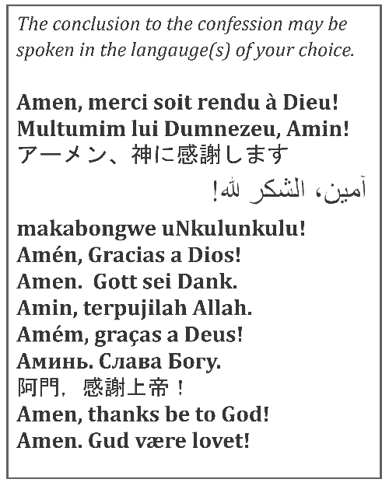
Dear ones, sinners and saints,
receive the good news:
patriarchy, misogyny, sexism,
homophobia, and white supremacy do not define you;
instead, God forgives you
and has imprinted love, grace, justice,
and abundant life on your hearts forever.
As we grieve, let us also trust in Jesus Christ’s power
to liberate this gathered assembly,
the church,
and the whole world.
Through the Spirit,
we shall be transformed
for God’s promised future.
Let the church say:
Amen. Thanks be to God!

OR

Alternate Brief Order of Confession and Forgiveness

The presiding minister begins.
Blessed be the holy Trinity, ☩ one God,
the Source of all life,
the Word embodied in Jesus,
the Spirit making us whole.
Amen.

Knowing that we fail to embody the abundant life God promises,
we offer confession before God and one another.

Silence is kept for reflection.

Holy Wisdom,
you have molded us in your image and breathed into us your Spirit.
Yet we value some people more fully than others.
You knit us together as one body in Christ.
Yet we make unnecessary divisions among your people.
You call us to pattern our lives on Christ’s loving service.
Yet we value rule by might and submission.

From our participation in patriarchal systems and values,
O God, deliver us.
From church policies and practices that undervalue the gifts and callings of women,
O God, deliver us.
From unjust laws that unduly burden women;
for women in poverty and girls with little or no access to education,
O God, deliver us.
From all gender-based violence justified by power and privilege,
O God, deliver us.

People of God, hear this promise:
God’s love is boundless. In Christ you are forgiven, restored to love as God loves you. As you have been forgiven, strive to love your neighbors, trusting God’s loving-kindness at work in you.
Amen.

Scripture Readings
When this Confession for the Sins of Patriarchy and Sexism was confessed at the 2025 ELCA Churchwide Assembly, it was included at an evening prayer service and the scripture selected was Luke 1:46-55. When set within the primary service of the congregation on a Sunday or festival, the readings for that Sunday or festival are normally used. If used outside of a Sunday worship, you may consider other options. You might consider:
- Scripture that celebrates women in the Bible, such as Miriam dancing at the sea (Exod. 15:20);
Jesus and the woman of Samaria (John 4); or the women sharing the good news of the resurrection (Luke 24).
- Scripture that opens up less-considered images for God (The “Scriptural Images for God” in
All Creation Sings [pp. 268–271] would be a helpful resource as a starting place).
- Scripture that celebrates the good news (for example, the “good news to the oppressed” and abundant flourishing promised by the prophets (see portions of Isa. 1, 61, 65, and 66 as well as Micah 6) and the freedom we have in Christ (Gal. 5:1 and John. 8:31-32, 36).
- Scripture passages associated with Pentecost, the power of Holy Spirit, or spiritual gifts (Acts 2: 1-21; Ps. 104; and 1 Cor. 12:1-18, 21-25) in which the Spirit falls on upon all without respect to age, gender, nationality, or ability.
- Scriptural stories and parables in the gospels that point to how Jesus Christ embodied God’s urgent and persistent desire for the well-being of all people yesterday, today, tomorrow, and in the promised, future life.
- Scripture passages in the book of Revelation that speak of the healing of the nations and close with a vision of new heavens and earth as the ultimate outcome of God’s resolve (Rev. 22:1-2).

You might also consider including non-biblical readings from “Forgive Us and Transform Us for the Life of the World.”

Prayers
Sample Prayers of Intercession
You are encouraged to craft prayers of intercession locally. The following format and suggested petitions may be used or adapted as appropriate in your context. You are encouraged to invite additional prayer concerns from the assembly.

The following or another introduction may begin the intercessions.
Trusting in our creating and mothering God,
let us pray for the church, those in need,
and all of God’s creation.

I invite your prayers for the church.
Petitions might include:
For pastors and deacons who are women seeking a call and for the call process…
For the courage to live into the social statements the church has adopted…
For women and other minorities who have been subjugated by patriarchal religious structures…
For church unity, even as the church celebrates difference…
For the leaders in your church, synod, community.
For global concerns related to female leadership…
For expansive use of language and imagery, and for continued imagination and inspiration as we are church in the world…
For the life of the world, we pray:
receive our prayer.

I invite your prayers for the creation.
Petitions might include:
For the will to recognize the inherent diversity in all creation that you have called “very good,” and to rejoice in difference in all its forms …
For women around the globe who work in agriculture and who do not earn a living wage and struggle to feed their families …
For the ways patriarchy and devaluing of creation intersect, and for wisdom to pursue paths of flourishing for all creatures…
For men and boys who are also confined and hurt by patriarchal systems…
For Indigenous and other communities pointing us to a reverent care for the earth, our home…
For the life of the world, we pray:
receive our prayer.

I invite your prayers for the nations.
Petitions might include:
For those who have been barred from education because of their gender …
For those harmed by overconsumption and unjust economic systems …
For ever-expanding tables in places of power, so that all welcome women’s voices …
For the life of the world, we pray:
receive our prayer.

I invite your prayers for those in need, especially those most affected by patriarchy and sexism.
Petitions might include:
For victims of sex trafficking and exploitation, of sexual assault and harassment …
For women to be heard and believed in our health care systems,
and for gender affirming care for all…
For those whose existence is denied or dismissed due to ability, race, or gender …
For those carrying undue burdens in providing food, shelter, and care for others …
For the life of the world, we pray:
receive our prayer.

Here other intercessions may be offered.

Let us give thanks for those who went before us, blazing a trail we follow yet today.
Petitions might include:
For the countless unnamed sisters without whom none of us would be here today …
For those who taught us to pray, sing, and care for our neighbors …
For prophets who prayed through their bold actions …
For women who first served as pastors, deacons, and bishops in this church …
And for those women and other ancestors in faith we name now …
For the life of the world, we pray:
receive our prayer.

The following may conclude the intercessions.
Under the care of your sheltering wings, we bring all our prayers,
trusting that you care for and hear us;
through Jesus Christ, our Wisdom and Guide.
Amen.
Additional Prayers
In place of or in addition to the prayers of intercession above, or for use in another part of the service or context, the following collects may be considered.

Mighty and merciful God, lover of justice and equity, you call us to support the weak, to help those who suffer, and to honor all people. By the power of your Holy Spirit, make us advocates for your justice and instruments of your peace, so that all may be reconciled in your beloved community; through Jesus Christ our Savior. Amen. (All Creation Sings, p. 47)

O God, your divinity transcends distinctions of gender, and through the generations you widen our awareness of human diversity. We gather here before you in our various expressions of gender identity, all of us one in Christ Jesus. Bring our society to peacefulness concerning a wider understanding of gender. Give courage and healing to those who express outwardly the gender they testify as gift from you. Open the church to their witness. We ask that with your creative Spirit you cultivate new relationships, mend old wounds, and nurture communities of respect, for the sake of the one who embraces all persons in love, Jesus Christ, our Savior. Amen. (All Creation Sings, p. 51)

O God, you made us in your own image and redeemed us through Jesus your Son. Look with compassion on the whole human family; take away the arrogance and hatred that infect our hearts; break down the walls that separate us; unite us in bonds of love; and, through our struggle and confusion, work to accomplish your purposes on earth; so that, in your good time, every people and nation may serve you in harmony around your heavenly throne; through Jesus Christ, our Savior and Lord. Amen. (Evangelical Lutheran Worship, p. 79)

Grant, O God, that your holy and life-giving Spirit may move every human heart; that the barriers dividing us may crumble, suspicions disappear, and hatreds cease; and that, with our divisions healed, we might live in justice and peace; through your Son, Jesus Christ our Lord. Amen. (Evangelical Lutheran Worship, p. 79)

God of endless love, ever caring, ever strong, always present, always just: In Jesus Christ you join to your own suffering the pain of all who have been hurt in body, mind, and spirit by those who betrayed the trust placed in them. Hear the cries of [ / our neighbors] who have been gravely harmed, and the cries of those who love them. Soothe their restless hearts with hope, steady their shaken spirits with faith. Grant that all who have been harmed may find peace in justice. We ask this through Christ our Lord.
Amen. (All Creation Sings, p. 50)

Mighty Jesus, living Word, soothe the bodies, souls, and minds of the victims of sexual violence / domestic violence / . Bring them peace, hope, comfort, and strength. Bring abusers to justice and prevent them from causing further harm. Stir up the heart of your church gathered here and around the world, that we value justice and healing over silence and shame. Show us the way to your righteousness, led by the voices of those who suffer. In Jesus’ name we pray. Amen.
(All Creation Sings, p. 53)

Judge of all the earth, God of justice, we bring before you all who abuse others. Turn the hearts of the violent from the way of evil. Bring them to full awareness of the damage they do, to true repentance, and to amendment of their lives, for the sake of Jesus Christ, our Savior and Lord. Amen. (Evangelical Lutheran Worship: Occasional Services for the Assembly, p. 409)

The Prayer of Lament (All Creation Sings, p. 61) could be contextualized for this purpose.

Blessing
With Miriam, prophet of God,
let us go forth, dancing for God’s liberation.
Amen.

With Mary, the mother of Jesus,
let us go forth, dwelling in God’s living Word.
Amen.

With Mary Magdelene, witness to the resurrection,
let us go forth, announcing abundant life for all.
Amen.

Empowered by that same spirit present through generations past,
moving among us now,
and carrying us into the future,
let us receive God’s blessing.

Holy and living Trinity,
Source of all life,
Word made flesh
transforming Spirit,
bless you now and always.
Amen.

Assembly Song Suggestions
The following is a list of suggested hymns and songs that may be appropriate. You may also consider additional hymns found in the PENTECOST, HOLY SPIRIT; CONFESSION, FORGIVENESS; COMMUNITY IN CHRIST; and JUSTICE, PEACE sections of the worship resources.

All Creation Sings
902 | Come Now, O God
904 | Come to Be Our Hope, O Jesus / Tú, Jesús, nuestra Esperanza/Vem, Jesus, nossa esperança
907 | Filled with Hope and Gratitude
948 | Womb of Life and Source of Being
971 | Come and Seek the Ways of Wisdom
987 | Guide My Feet
1001/1002 | Holy Woman, Graceful Giver
1005 | Ask the Complicated Questions?
1009 | Come, Bring Your Burdens to God
1015 | As a Mother Comforts Her Child
1016 | Cast Out, O Christ
1036 | Commonwealth Is God’s Commandment
1047 | What Is the World Like
1062 | Build a Longer Table
1094 | Bring Many Names

Evangelical Lutheran Worship
358 | Great God Your Love Has Called Us
390 | The Risen Christ
397 | Loving Spirit
399 | O Holy Spirit, Root of Life
401 | Gracious Spirit, Heed our Pleading / Njoo kwetu, Roho mwema
403 | Like the Murmur of the Dove’s Song
407 | O Living Breath of God/Soplo de Dios vivente
412 | Come, Join the Dance of Trinity
419 | For All the Faithful Women
573 | My Soul Now Magnifies the Lord
603 | God, When Human Bonds Are Broken
643 | We Are All One in Christ Jesus/Somos uno en Cristo
650 | In Christ There Is No East or West
651 | Oh, Praise the Gracious Power
672 | Signs and Wonders
704 | When Pain of the World Surrounds Us
705 | God of Grace and God of Glory
706 | The People Walk / Un pueblo que camina
710 | Let Streams of Living Justice
723 | Canticle of the Turning
726 | Light Dawns on a Weary World
729 | The Church of Christ, in Every Age

Additional Resources
“Faith, Sexism, and Justice: A Call to Action” Social Statement adopted by the 2019 ELCA Churchwide Assembly. Also available in Spanish.

“Faith, Sexism, and Justice: A Call to Action Study Guide”

“Forgive Us and Transform Us for the Life of the World” Learn more about patriarchy and gender justice through stories, essays and art created by ELCA members.

ELCA Gender Justice and Women’s Empowerment website

Lowe, Mary Elise and Mary J. Streufert. Reengaging ELCA Social Teaching on Faith, Sexism, and Justice, Augsburg Fortress, 2025.

Copyright © 2026 Evangelical Lutheran Church in America
Material in this document may be reproduced for local, non-sale use only.

